
Crop Protection
BASF SE, 67114 Limburgerhof, Deutschland

4630/m
FIPRONIL
581

CIPAC 581, HPLC method

by

Dr. Christoph Randt and Brigitte Przywara
BASF SE
BASF Agricultural Center Limburgerhof
Crop Protection - Global Analytics
D-67114 Limburgerhof
GERMANY

FIPRONIL

581

ISO common name Fipronil
Chemical name (±)- 5-Amino-1-[2,6-dichloro-4-(trifluoromethyl)phenyl]-4-trifluoromethylsulphinylpyrazol-3-carbonitrile (IUPAC);
(±)- 5-Amino-1-[2,6-dichloro-4-(trifluoromethyl)phenyl]-4-trifluoromethyl)-sulphinyl]-1H-pyrazole-3-carbonitrile (CA)
CAS.No. 120068-37-3
Empirical formula C₁₂H₄Cl₂F₆N₄OS
RMM 437.2
m.p. 195.5° C – 203°C
v.p. 3.7 x 10^{–7} mPa at 25° C
Solubility In water: 2.4 mg/l at pH 5; acetone: 545.9 g/l; methanol 137.5 g/l; propan-2-ol: 36.2 g/l; octanol-1: 12.2 g/l; dichloromethane: 22.3 g/l; hexane: 28 g/l; ethyl acetate: 264.9 g/l; toluene: 3 g/l; all at 20 °C
Description White to yellowish crystalline powder
Formulations Ultra low volume liquid, emulsifiable concentrates, flowable concentrate for seed treatment, suspension concentrate; granules, water dispersible granules; fine granules

Fipronil technical
*581/TC/M/-

1 Sampling. Take at least 100 g.

2 Identity tests
2.1 HPLC. Use the HPLC method below. The relative retention time of the Fipronil peak in the sample solution should not differ by more than 2% from that of the calibration solution.
2.2 Infrared. Prepare potassium bromide discs from the sample and from pure fipronil using about 1 mg of material and 350 mg of potassium bromide. Scan the discs from 4000 to 400 cm⁻¹. The spectrum produced from the sample should not differ significantly from that of the standard (Fig. 18).

3 Fipronil
OUTLINE OF METHOD. Fipronil is determined by high performance liquid chromatography on a reversed phase column with UV detection using the external standard method.

REAGENTS

Water HPLC grade

Fipronil analytical standard of known purity
Acetonitrile HPLC grade
Propan-2-ol HPLC-grade
Mobile phase water – acetonitrile, 35 + 65 (v/v)
Calibration solution Weigh in duplicate (to the nearest 0.1 mg) about 25 mg (s mg) of fipronil standard into separate volumetric flasks (100 ml). Add propan-2-ol into each flask and place the flasks in an ultrasonic bath for approximately 10 min. Dilute to volume with propan-2-ol and mix thoroughly (solutions C₁ and C₂).

APPARATUS

Liquid chromatograph equipped with a constant flow pump, an automatic injector, a column oven, a UV detector capapbe of measuring at 280 nm
Integrator or data acquisition system
Column Nucleosil C₁₈ (5 µm); 250 x 4 mm (i. d) or equivalent

Ultrasonic bath

* CIPAC method 2000. Prepared by the French Committee (CFAPA). Chairman: B. Declercq. Based on a method supplied by Rhône-Poulenc Agro, France.

PROCEDURE

(a) Operating conditions (typical)
Flow rate 1 ml/min
Column temperature 40 °C
Injection volume 5 µl
Retention time about 6 min
Run time 30 min

(b) Preparation of the sample Weigh (to the nearest 0.1 mg) 25 ± 5 mg (w mg) of technical Fipronil into a volumetric flask (100 ml). Add propan-2-ol to the flask and place the flask in an ultrasonic bath for approximately 10 min. Dilute to volume with propan-2-ol and mix thoroughly (Solution S).

(c) Determination. Inject 5 µl of the calibration solution C₁ until the consecutive relative response factors agree within 1%. Then, inject the calibration and sample solutions in the following sequence:

C₁, S, S, C₂,…

(d) Calculation. Calculate the relative response factors (f₁, f₂) for the pair of calibration injections that bracket the sample injections and obtain the mean response factor f.

$$f=\frac{s×P}{H_{s}}$$

where:
H_{s} = area of the Fipronil peak in the calibration solution
s = mass of Fipronil standard in the calibration solution (mg)
P = purity of Fipronil standard (g/kg)

Calculate the fipronil content for each sample injection, and calculate the mean of the two values as the fipronil content in the sample.

Content of fipronil $=\frac{f×H_{w}}{w}$ (g/kg)

where:
H_{w} = area of the Fipronil peak in the sample solution
$f$ = mean response factor
w = mass of sample in the sample solution (mg)

Repeatibility r = 24 g/kg at 957 g/kg active ingredient content
Reproducibility R = 31 g/kg at 957 g/kg active ingredient content

Fipronil FLOWABLE CONCENTRATE FOR SEED TREATMENT

*581/FS/M/-

1 Sampling. Take at least 100 ml.

2 Identity tests
2.1 HPLC. As for Fipronil technical 581/TC/M/2.1
2.2 UV spectrometry. Use a diode array detector and measure at the top of the fipronil peak, wavelength 190 – 400 nm. The spectra of the sample and the reference have to be identical.

3 Fipronil

As for technical 581 TC/M/3 except:

Calibration solution. Calculate the amount of Fipronil, analytical standard of known purity, suitable to the expected concentration in the sample solution. For example, weigh in duplicate (to the nearest 0.1 mg) about 10 mg or 50 mg of Fipronil, depending on the concentration of the active ingredient in the formulation, into a volumetric flask (100 ml). Add 60 ml propan-2-ol. Sonicate for 10 minutes at ambient temperature. Add 10 ml of water and approx. 20 ml propan-2-ol and mix carefully. Equilibrate to ambient temperature, fill up to volume with propan-2-ol and mix thoroughly (solutions C₁ and C₂).

(b) Preparation of the sample Weigh (to the nearest 0.1 mg) a calculated amount of sample corresponding to the expected amount of Fipronil, e. g. 200 mg, into a volumetric flask (100 ml). Add 10 ml of water and mix carefully. Add 60 ml propan-2-ol and mix again. Sonicate for 10 minutes at ambient temperature. Add approx. 20 ml of propan-2-ol, equilibrate to ambient temperature, fill up to volume with propan-2-ol, mix thoroughly and filtrate if necessary (Solution S).

Fipronil SUSPENSION CONCENTRATE

*581/SC/M/-

1 Sampling. Take at least 100 ml.

2 Identity test
2.1 HPLC. As for Fipronil technical 581/TC/M/2.1
2.2 UV spectrometry. As for Fipronil 581/FS/M/2.2

3 Fipronil

As for 581 FS/M/3

* CIPAC method 2000. Prepared by the French Committee (CFAPA). Chairman: B. Declercq. Based on a method supplied by Rhône-Poulenc Agro, France.

Fipronil WATER DISPERSIBLE GRANULES

*581/WG/M/-

1 Sampling. Take at least 100 g.

2 Identity tests
2.1 HPLC. As for Fipronil technical 581/TC/M/2.1
2.2 UV spectrometry. As for Fipronil 581/FS/M/2.2

3 Fipronil

As for 581 FS/M/3 except

(b) Preparation of the sample Weigh (to the nearest 0.1 mg) a calculated amount of sample corresponding to the expected amount of Fipronil, e.g. 60 mg into a volumetric flask (100 ml). Add 10 ml of water and mix carefully. Add 60 ml propane-2-ol, sonicate for 10 minutes at ambient temperature. Add approx. 20 ml of propan-2-ol, equilibrate to ambient temperature, fill up to volume with propan-2-ol, mix thoroughly and filtrate if necessary (Solution S).

Fipronil GRANULES

*581/GR/M/-

1 Sampling. Take at least 100 g.

2 Identity test
2.1 HPLC. As for Fipronil technical 581/TC/M/2.1
2.2 UV spectrometry. As for Fipronil 581/FS/M/2.2

3 Fipronil

As for 581 WG/M/3 except

(b) Preparation of the sample Weigh (to the nearest 0.1 mg) a calculated amount of sample corresponding to the expected amount of Fipronil, e.g. 1000 mg into a volumetric flask (100 ml). Add 10 ml of water and mix carefully. Sonicate for 10 minutes at ambient temperature, add 60 ml propan-2-ol and mix again. Sonicate for 10 minutes at ambient temperature, add approx. 20 ml of propan-2-ol, equilibrate to ambient temperature, fill up to volume with propan-2-ol, mix thoroughly and filtrate if necessary (Solution S).

Fipronil FINE GRANULES

*581/FG/M/-

1 Sampling. Take at least 100 g.

2 Identity test
2.1 HPLC. As for Fipronil technical 581/TC/M/2.1
2.2 UV spectrometry. As for Fipronil 581/FS/M/2.2

* CIPAC method 2000. Prepared by the French Committee (CFAPA). Chairman: B. Declercq. Based on a method supplied by Rhône-Poulenc Agro, France.

3 Fipronil

As for 581 WG/M/3 except

(b) Preparation of the sample Weigh (to the nearest 0.1 mg) a calculated amount of sample corresponding to the expected amount of Fipronil, e.g. 500 mg into a volumetric flask (100 ml). Add 10 ml of water and mix carefully. Add 60 ml propan-2-ol. Sonicate for 10 minutes at ambient temperature, add approx. 20 ml of propan-2-ol, equilibrate to ambient temperature, fill up to volume with propan-2-ol, mix thoroughly and filtrate if necessary (Solution S).

Fipronil EMULSIfiable CONCENTRATES

*581/EC/M/-

1 Sampling. Take at least 50 ml.

2 Identity tests
2.1 HPLC. As for Fipronil technical 581/TC/M/2.1

3 Fipronil

As for technical 581 TC/M/3

* CIPAC method 2000. Prepared by the French Committee (CFAPA). Chairman: B. Declercq. Based on a method supplied by Rhône-Poulenc Agro, France.

Typical Chromatograms of Fipronil

Figure 1 Analytical Standard Fipronil
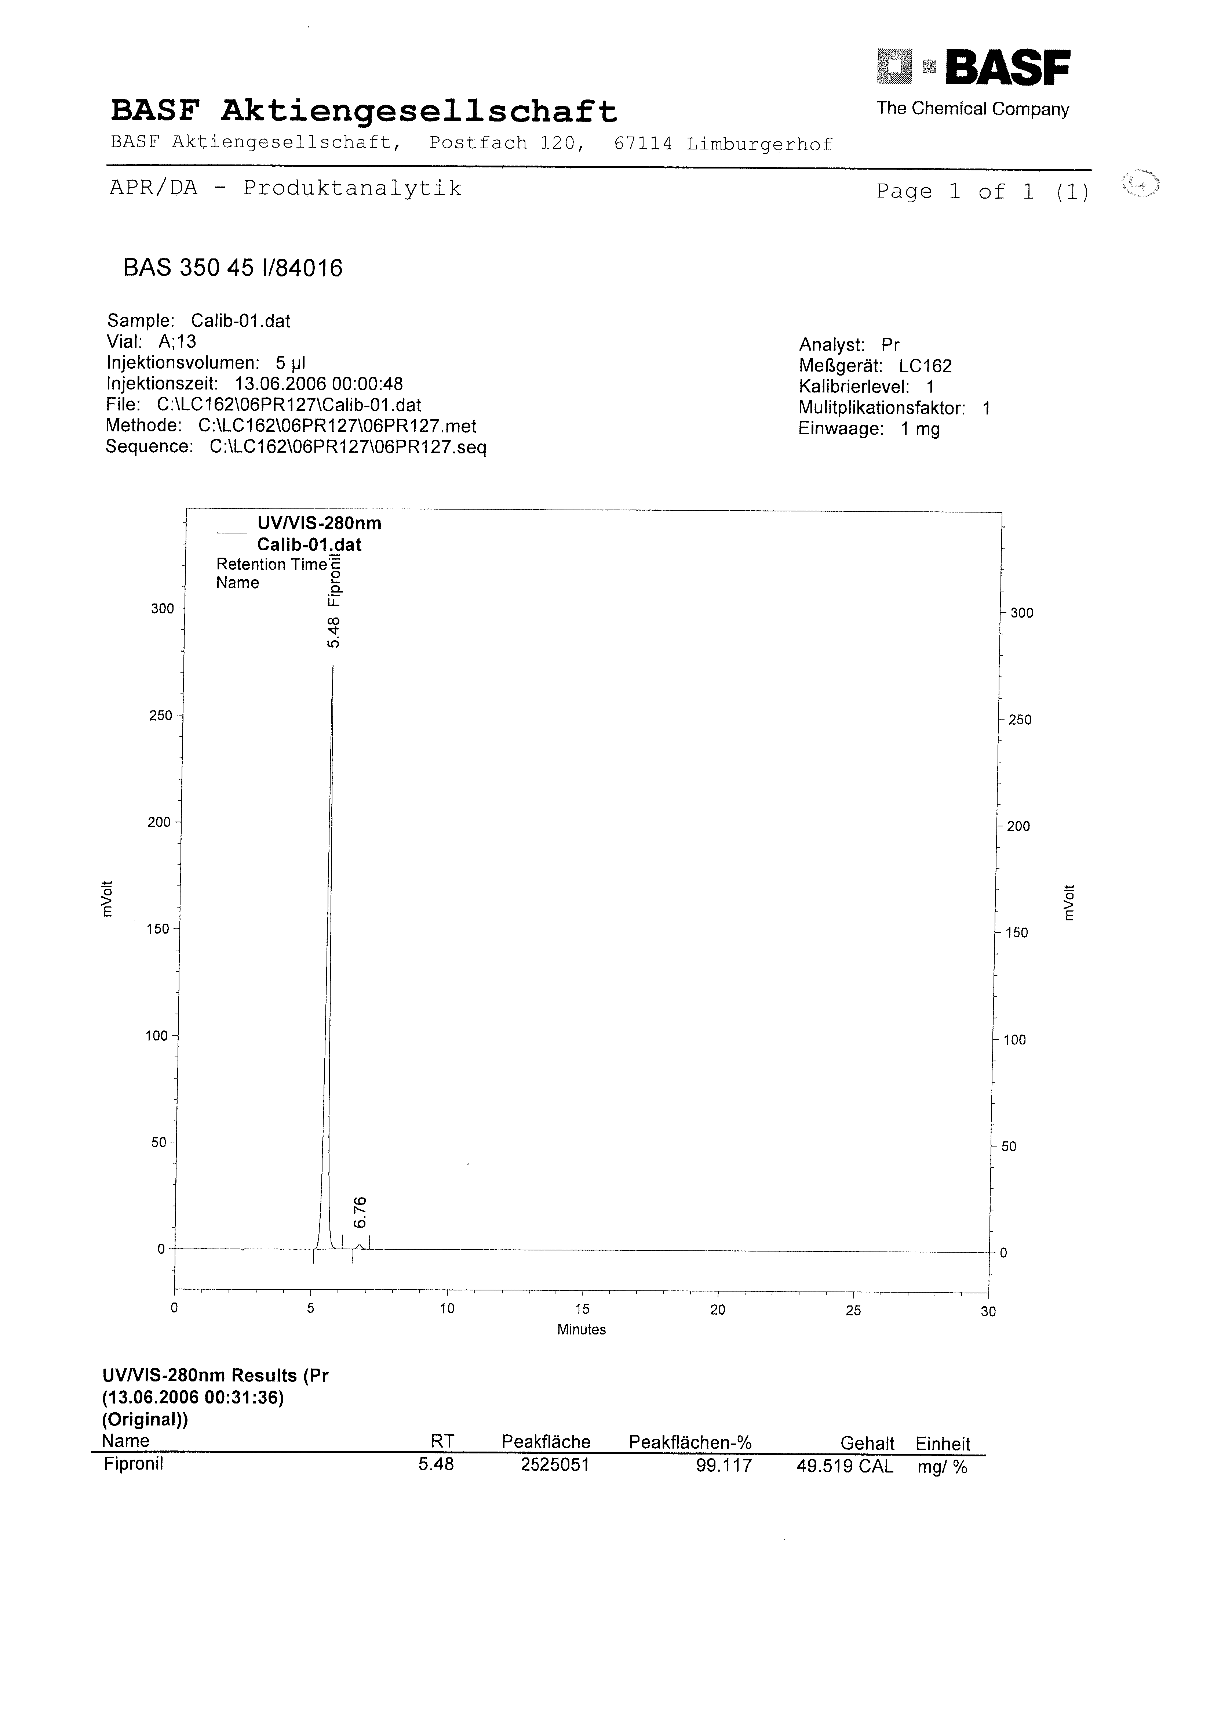

Figure 2 Technical Material TC
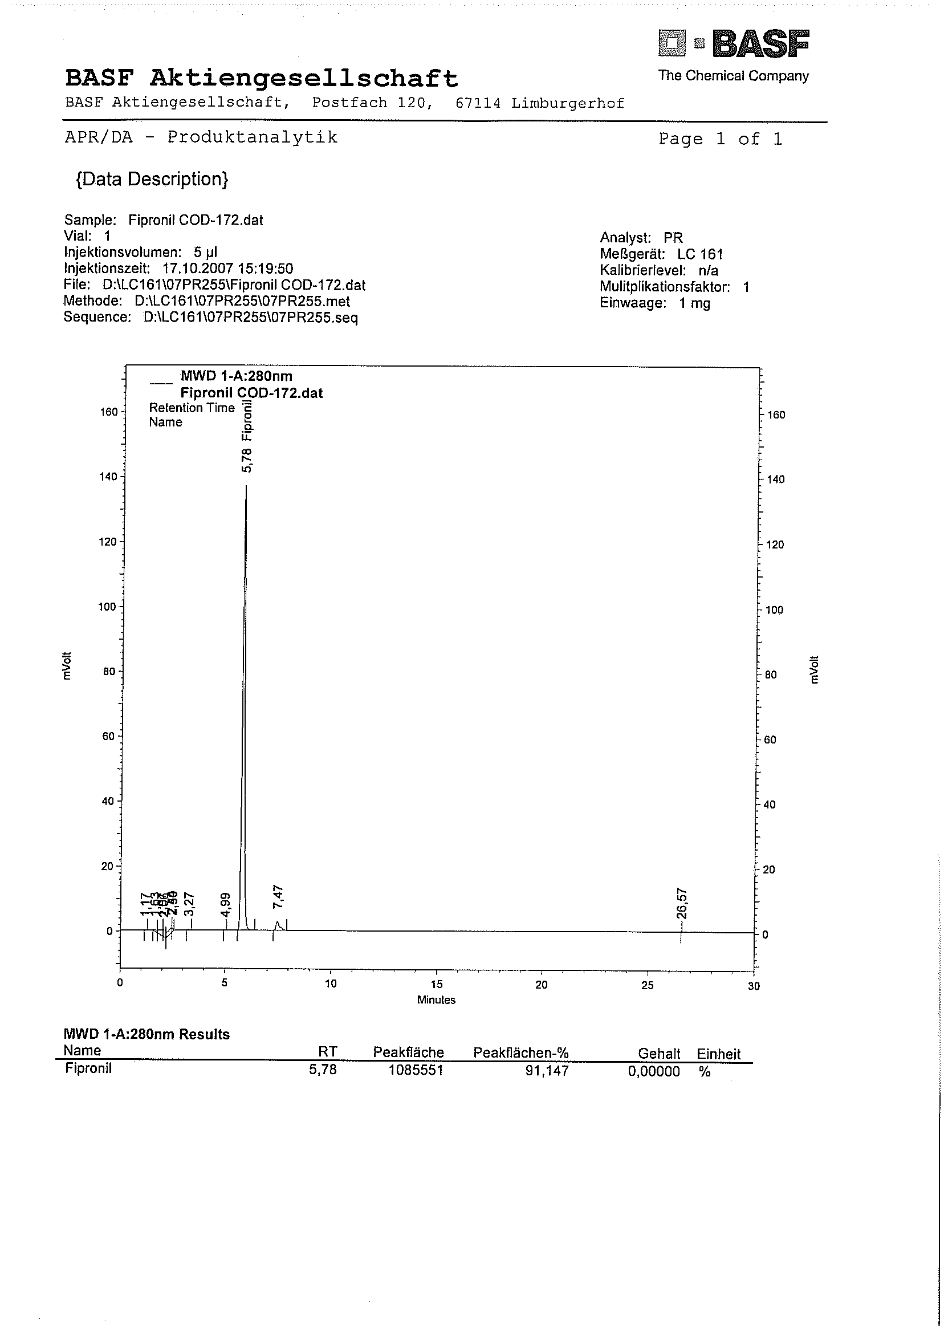

Figure 3 Flowable Concentrate for Seed Treatment FS
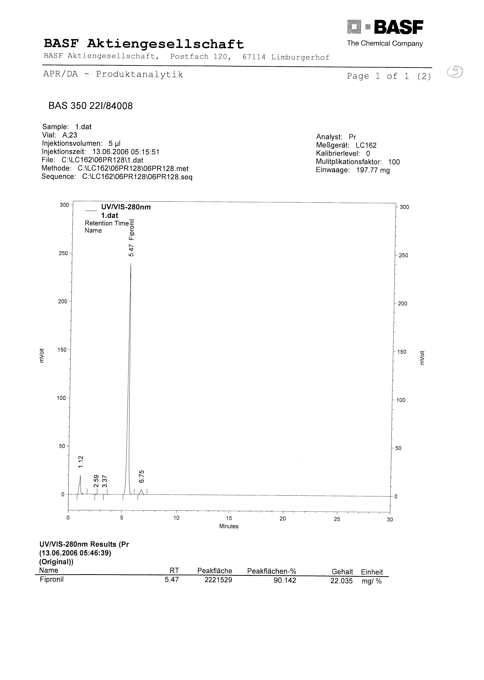

Figure 4 Suspension Concentrate SC
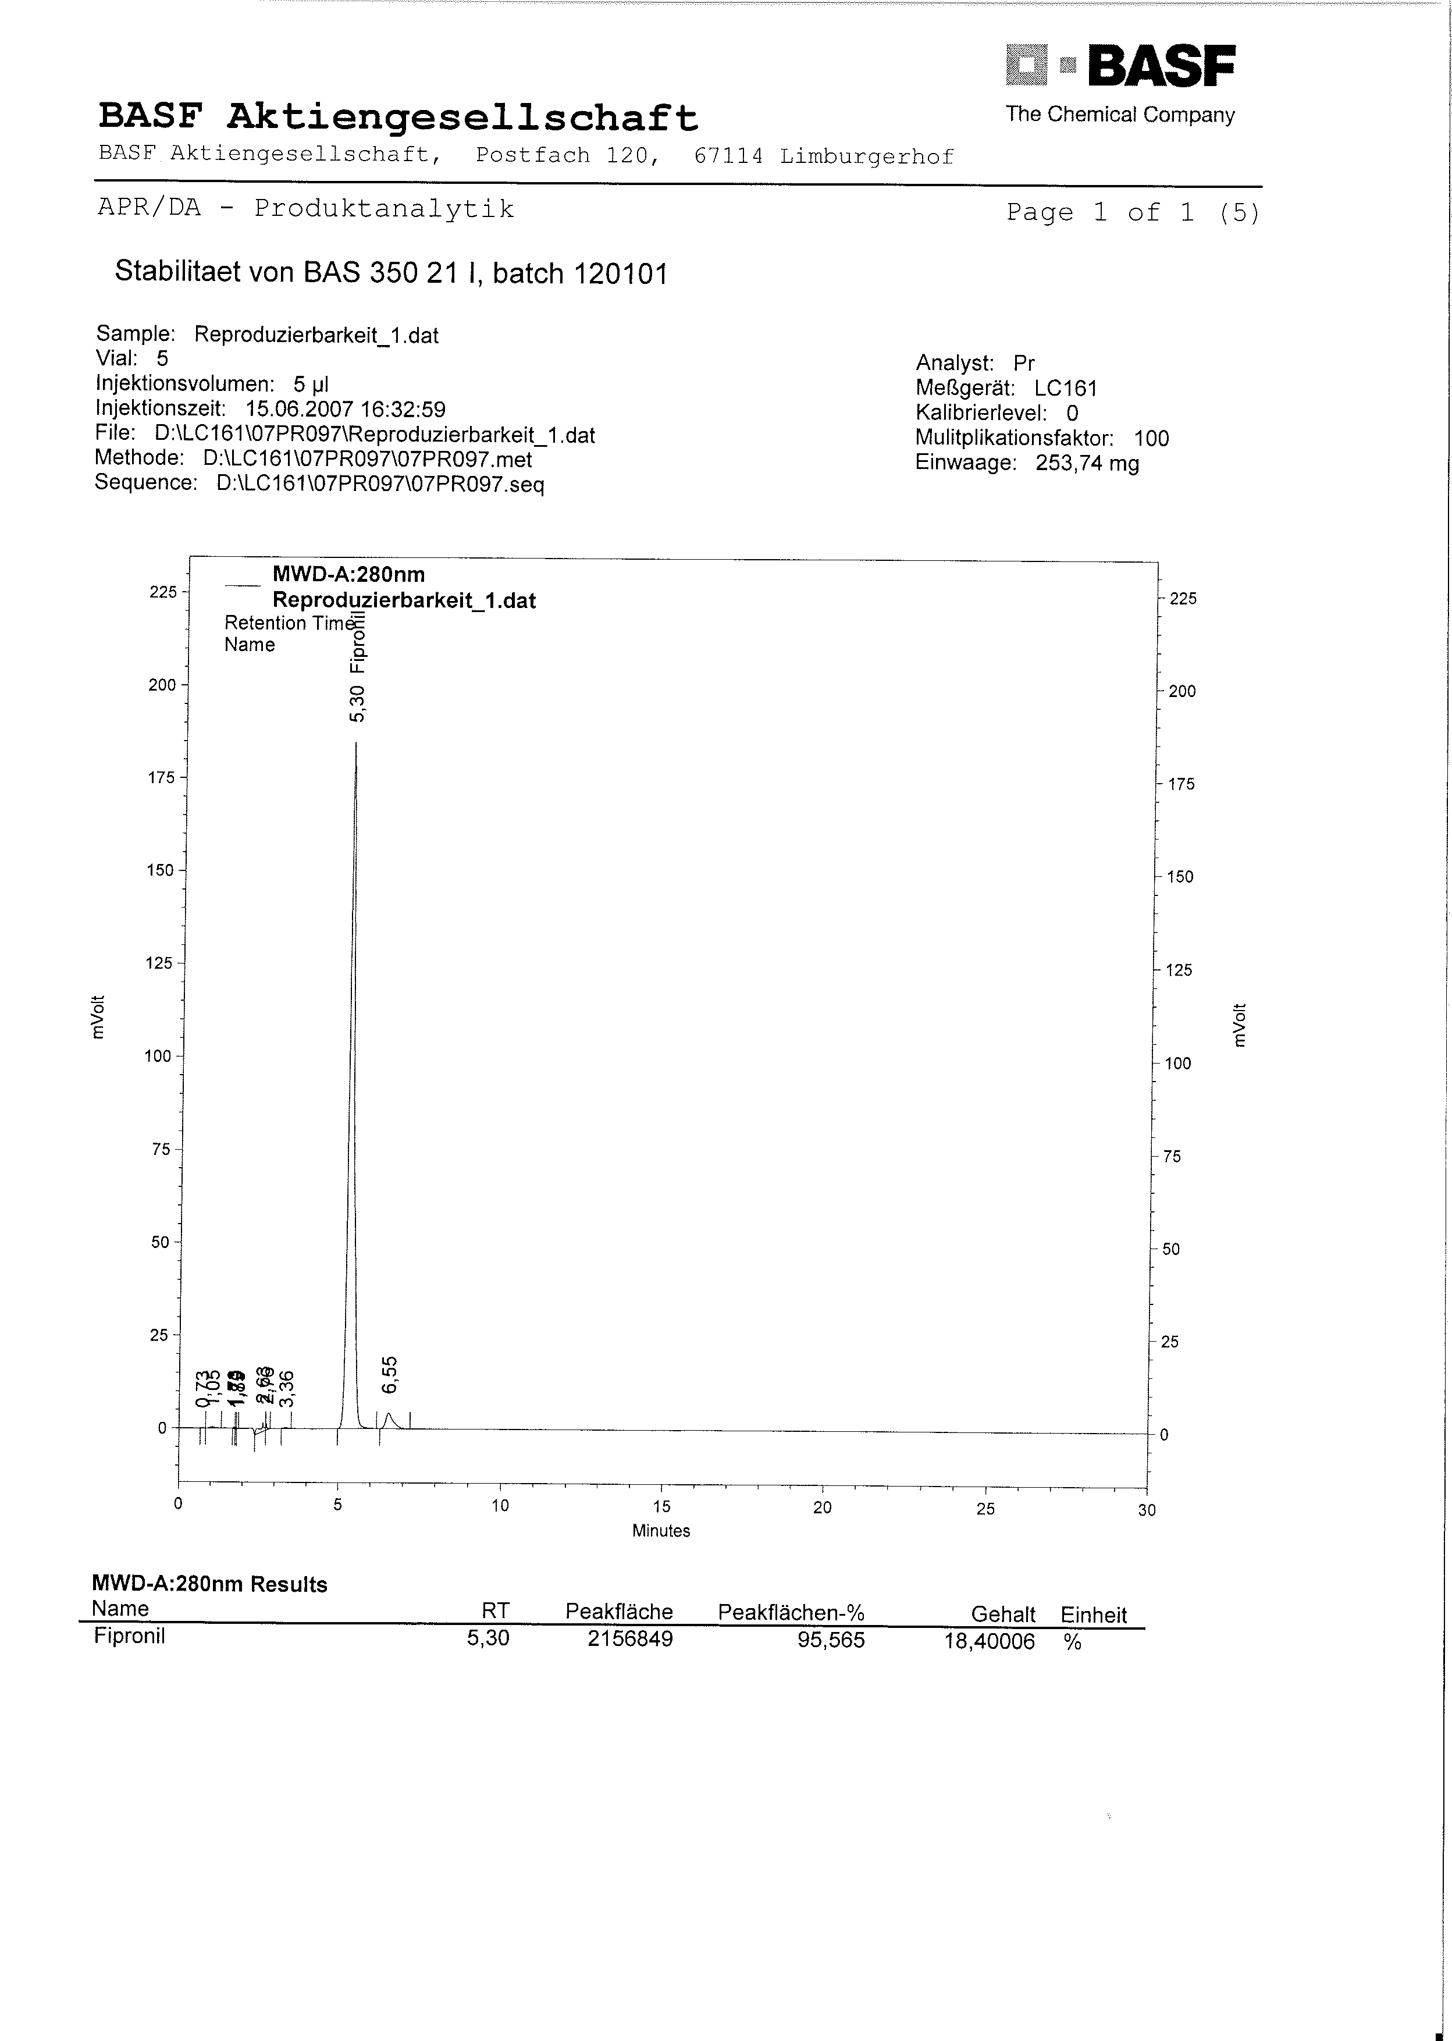

Figure 5 Water Dispersible Granules WG
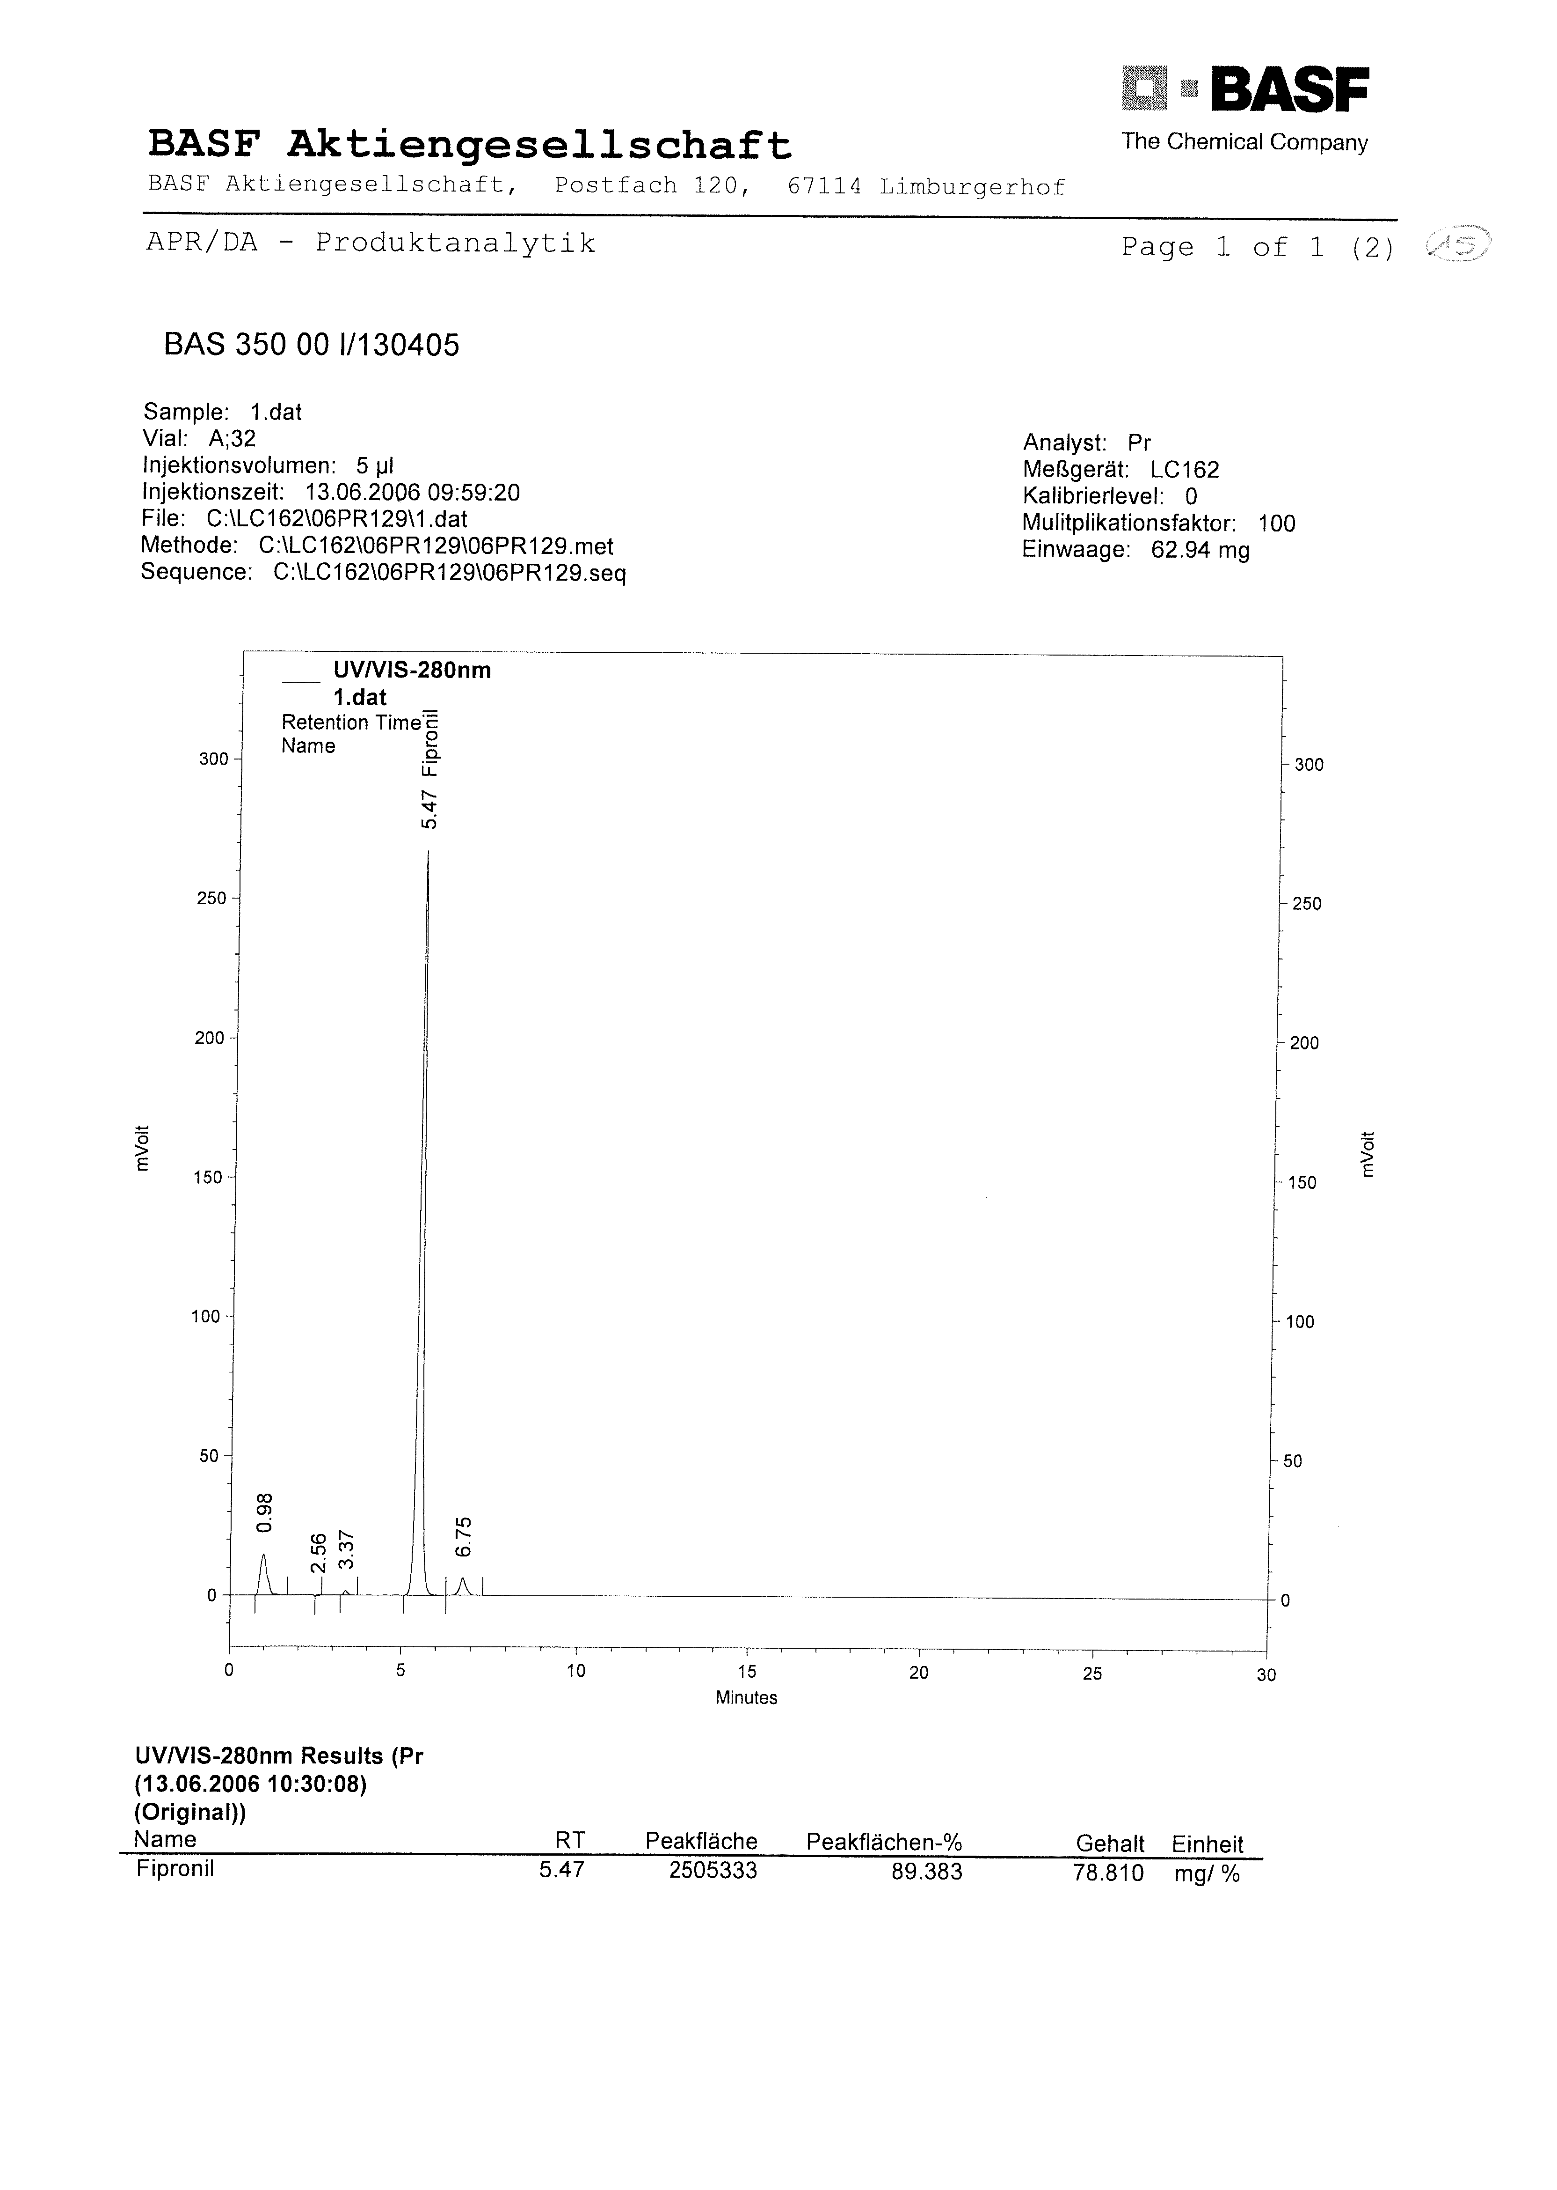

Figure 6 Granules GR
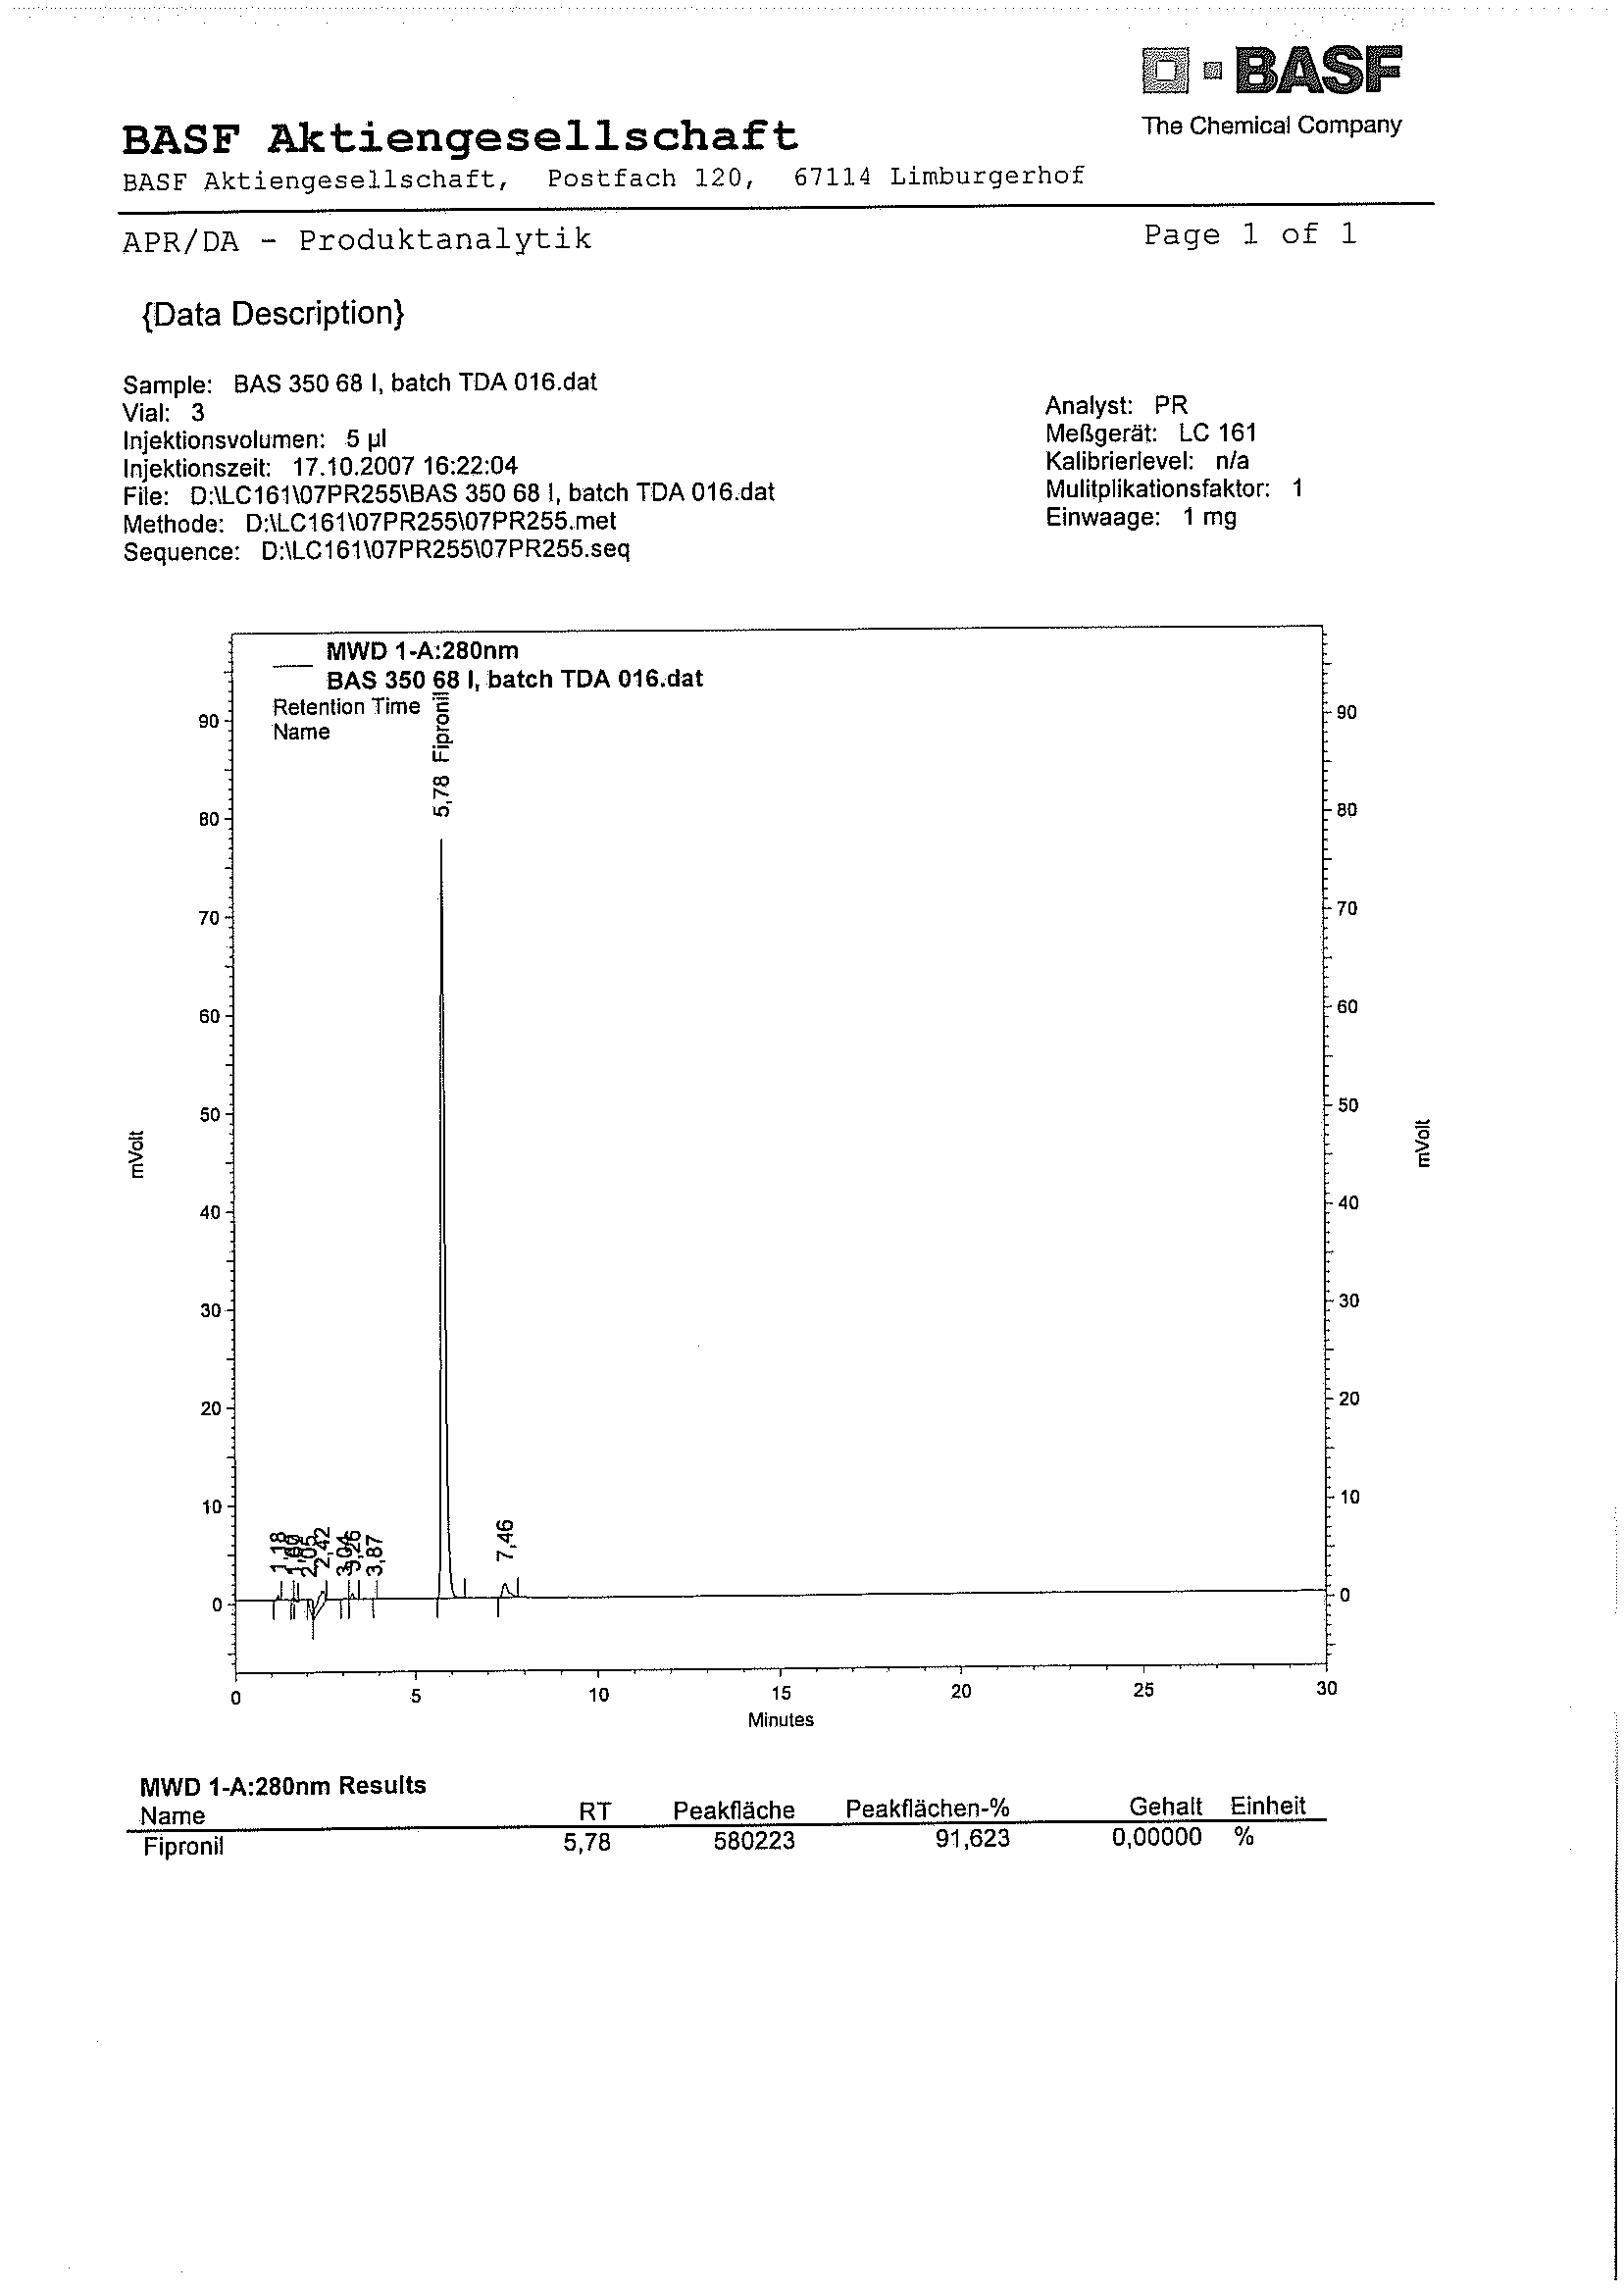

Figure 7 Fine Granules FG
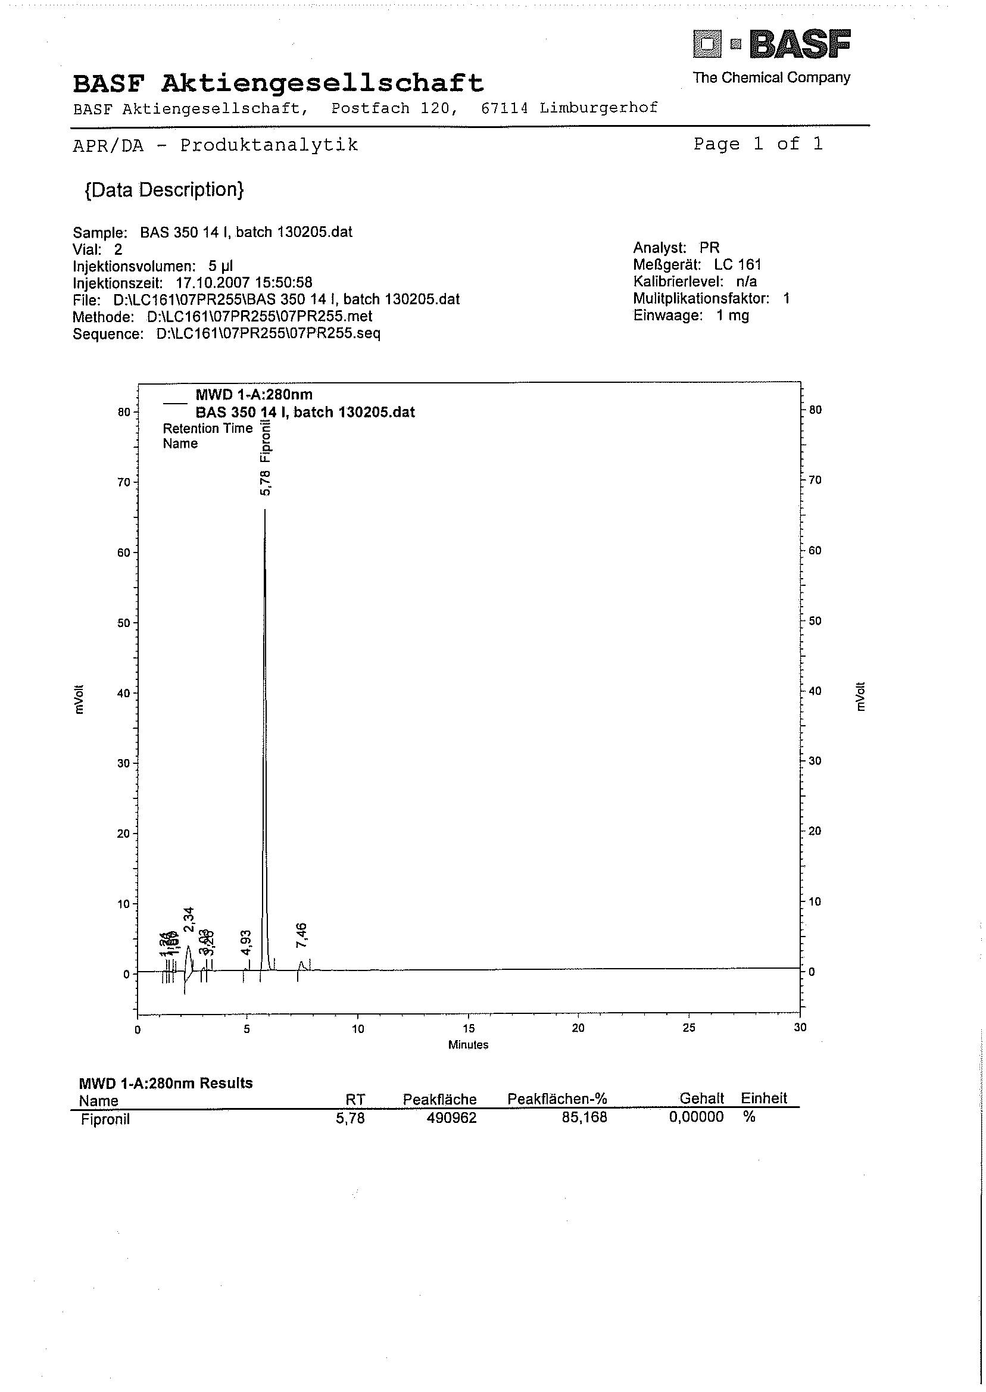

Fipronil EMULSIFIABLE CONCENTRATE
*581/EC/M/-

1 Sampling. Take at least 100 g.

2 Identity tests
2.1 HPLC. As for 581/TC/M/2.1.
2.2 Mass spectrometry. Dissolve about 500 µl of sample in propan-2-ol. Inject 5 µl of the solution through the APCI flown with a water - acetonitrile, 50 + 50 (v/v) at 0.2 ml/min and operated with a 20 V cone. Scan from 100 to 800 m.a.u. in 2 s. The following three fragments should be observed:
m/z = 435 [(M - H)⁻ with two ³⁵Cl]
m/z = 366 {[(M - H) - CF₃]⁻ with two ³⁵Cl]}
m/z = 331 {[(M - H) - CF₃ - Cl]⁻ with one ³⁵Cl]}

3 Fipronil

As for 581/TC/M/3 except:

(b) Preparation of sample. Weigh (to the nearest 0.1 mg) sufficient sample to contain about 25 mg (w mg) of fipronil into a volumetric flask (100 ml). Add propan-2-ol into the flask and place the flask in an ultrasonic bath for approximately 10 min. Dilute to volume with propan-2-ol and mix thoroughly (solution S).

Repeatability r = 1.0 g/kg at 42.4 g/kg active ingredient content
Reproducibility R = 1.6 g/kg at 42.4 g/kg active ingredient content

Fipronil ULTRA LOW VOLUME LIQUID
*581/UL/M/-

1 Sampling. Take at least 100 g.

2 Identity tests
2.1 HPLC. As for 581/TC/M/2.1.
2.2 Mass spectrometry. As for 581/EC/M/2.2.

* CIPAC method 2000. Prepared by the French Committee (CFAPA). Chairman: B. Declercq. Based on a method supplied by Rhône-Poulenc Agro, France.

3 Fipronil.

As for 581/TC/M/3 except:

(b) Preparation of sample. Weigh (to the nearest 0.1 mg) sufficient sample to contain about 25 mg (w mg) of fipronil into a volumetric flask (100 ml). Add propan-2-ol into the flask and place the flask in an ultrasonic bath for approximately 10 min. Dilute to volume with propan-2-ol and mix thoroughly (solution S).

Repeatability r = 1.5 g/kg at 25.8 g/kg active ingredient content
Reproducibility R = 1.8 g/kg at 25.8 g/kg active ingredient content

Repeatability r = 0.2 g/kg at 6.8 g/kg active ingredient content
Reproducibility R = 0.6 g/kg at 6.8 g/kg active ingredient content

Figure 8 Chromatogram of fipronil

Figure 9 IR spectrum of fipronil

*
*
*
*
*
*
*
*
*

